1. Write a program to calculate the sum of the first 50 natural numbers.   
Input:  
class NaturalNumber{

public static void main(String args[]){

int sum=0;

for(int i=1;i<=50;i++)

{

sum=sum+i;

}

System.out.println("Sum of first 50 natural numbers is: "+sum);

}

}  
output: 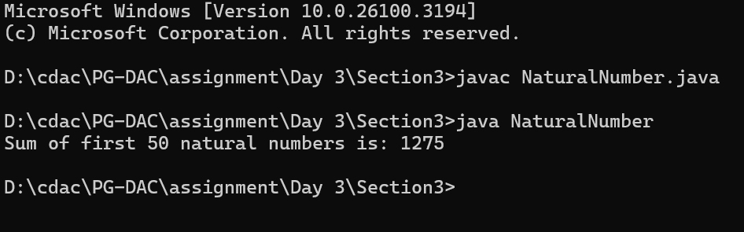

2. Write a program to compute the factorial of the number 10.

Input:  
class Factorial{

public static void main(String args[]){

int fact=1;

for(int i=10;i>=1;i--)

{

fact= fact \* i;

}

System.out.println("Factorial of 10= "+fact);

}

}

Output:  
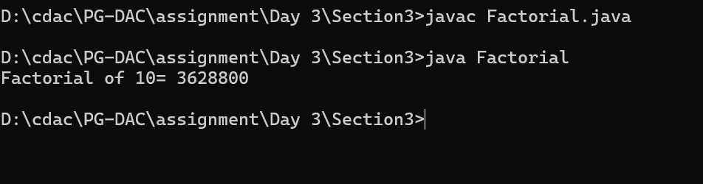

3. Write a program to print all multiples of 7 between 1 and 100.

Input:  
class Multiples{

public static void main(String args[]){

int div=0;

System.out.print("Number divisible by 7 are: ");

for(int i=1;i<=100;i++)

{

if(i%7==0)

{

System.out.print(i+", ");

}

}

}

}

Output:  
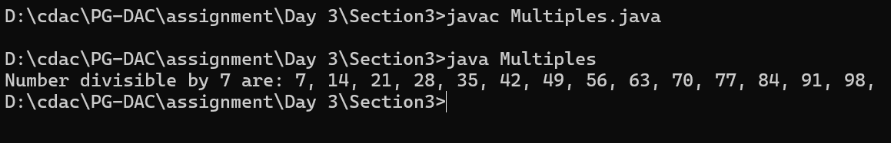

4. Write a program to reverse the digits of the number 1234. The output should be 4321.

Input:  
class Reverse{

public static void main(String[] args) {

int num = 1234;

int reverse = 0;

while (num != 0) {

int digit = num % 10;

reverse = reverse \* 10 + digit;

num /= 10;

}

System.out.println("The reverse of the number is " + reverse);

}

}

Output:

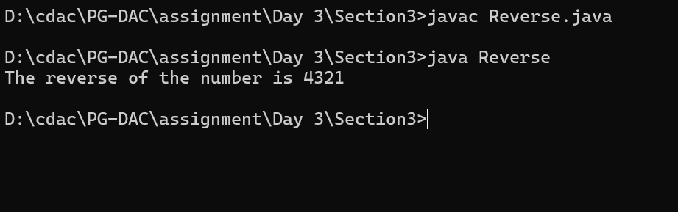

5. Write a program to print the Fibonacci sequence up to the number 21.

Input:  
class Fibonacci{

public static void main(String args[]){

int f0=0;

int f1=1;

System.out.print("Fibonacci series upto 21 number are: ");

System.out.print(f0+","+f1+",");

for(int i=1;i<=19;i++)

{

int f=f0+f1;

System.out.print(f+",");

f0=f1;

f1=f;

}

}

}

Output:

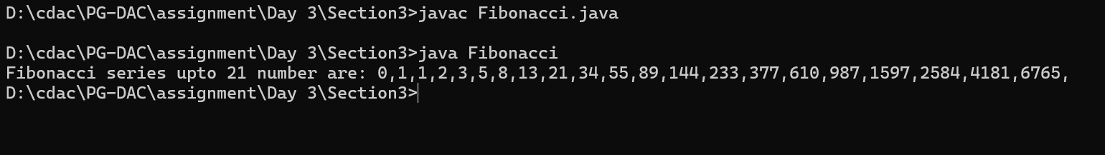

6. Write a program to find and print the first 5 prime numbers.

Input:  
public class Prime {

public static void main(String[] args) {

System.out.println("First 5 prime numbers are:");

int n = 2;

int count = 0;

while (count < 5) {

int c = 0;

for (int i = 2; i < n; i++) {

if (n % i == 0) {

c++;

break;

}

}

if (c == 0) {

System.out.print(n+",");

count++;

}

n++;

}

}

}

Output:

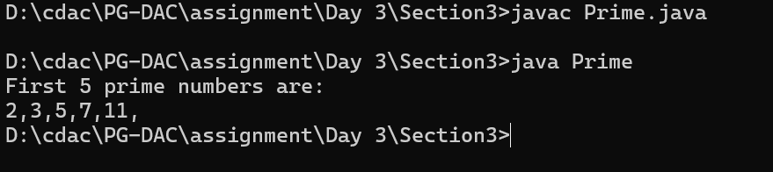

7. Write a program to calculate the sum of the digits of the number 9876. The output should be 30 (9 + 8 + 7 + 6).

Input:

public class Digits {

public static void main(String[] args) {

int num = 9876;

int sum = 0;

while (num > 0) {

sum = sum + num % 10;

num = num/ 10;

}

System.out.println( " Sum of digit 9876 is:"+sum );

}

}

Output:

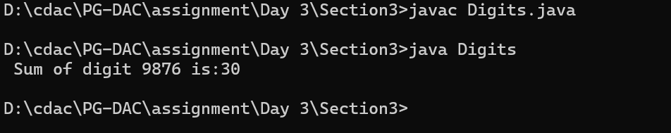

8. Write a program to count down from 10 to 0, printing each number.

Input:

public class CountDown{

public static void main(String[] args) {

for(int i=10;i>=0;i--)

{

System.out.println(i);

}

}

}

Output:

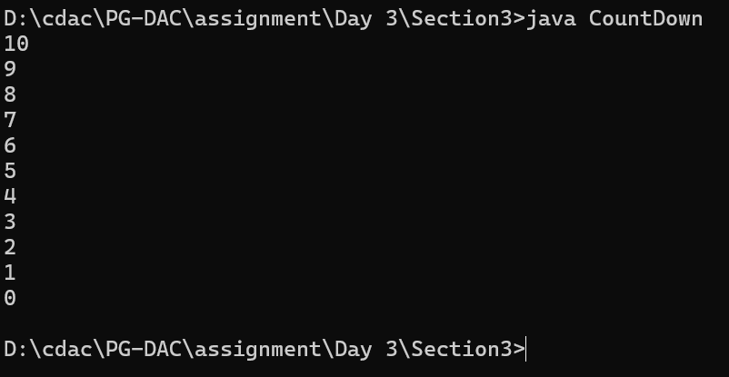

9. Write a program to find and print the largest digit in the number 4825.

Input:

public class LargestDigit {

public static void main(String[] args) {

int num = 4825;

int maxDigit = 0;

while (num > 0)

{

int digit = num % 10;

if (digit > maxDigit)

{

maxDigit = digit;

}

num /= 10;

}

System.out.println("Largest digit: " + maxDigit);

}

}

Output:

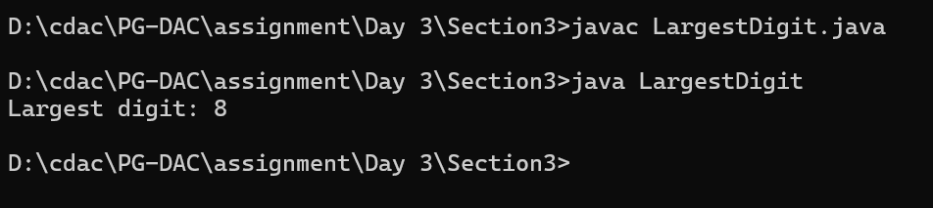

10. Write a program to print all even numbers between 1 and 50.

Input:

public class Even {

public static void main(String[] args) {

System.out.println("First 50 even number are: ");

for(int i=1;i<=50;i++)

{

if(i%2==0)

{

System.out.print(i+", ");

}

}

}

}

Output:

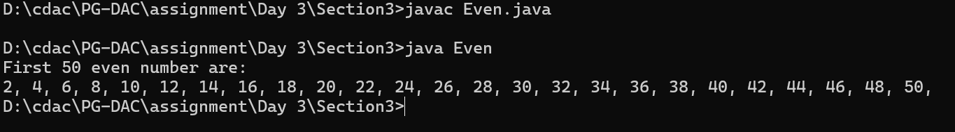

11. Write a Java program to demonstrate the use of both pre-increment and post-decrement

operators in a single expression

Input:

public class Incriment{

public static void main(String[] args) {

int i = 5;

int result = ++i - i--;

System.out.println("Initial value of i: 5");

System.out.println("Value after pre-increment (++i): " + (i + 1));

System.out.println("Value after post-decrement (i--): " + i);

System.out.println("Result of the expression (++i - i--): " + result);

System.out.println("Final value of i: " + i);

}

}

Output:

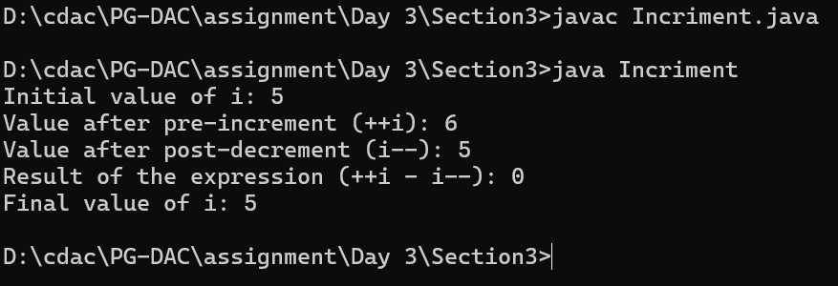

12. Write a program to draw the following pattern:

\*\*\*\*\*

\*\*\*\*\*

\*\*\*\*\*

\*\*\*\*\*

\*\*\*\*\*

Input:

class Pattern1{

public static void main(String args[]){

for(int i=1; i<6;i++)

{

for(int j=1; j<=5;j++)

{

System.out.print("\*");

}

System.out.println();

}

}

}

Output:

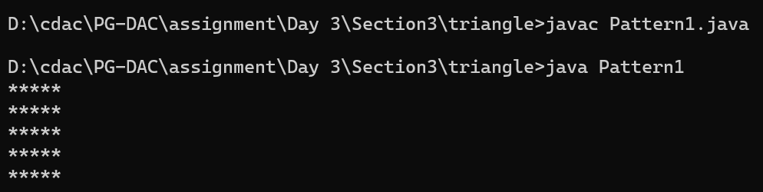

13. Write a program to print the following pattern:

1

2\*2

3\*3\*3

4\*4\*4\*4

5\*5\*5\*5\*5

5\*5\*5\*5\*5

4\*4\*4\*4

3\*3\*3

2\*2

1

Input:

class Pattern2{

public static void main(String args[]){

for(int i=1; i<6;i++)

{

for(int j=1; j<=i;j++)

{

System.out.print(i);

if(j<i)

{

System.out.print("\*");

}

}

System.out.println();

}

//Lower triangle

for(int i=5; i>0;i--)

{

for(int j=1; j<=i;j++)

{

System.out.print(i);

if(j<i)

{

System.out.print("\*");

}

}

System.out.println();

}

}

}

Output:

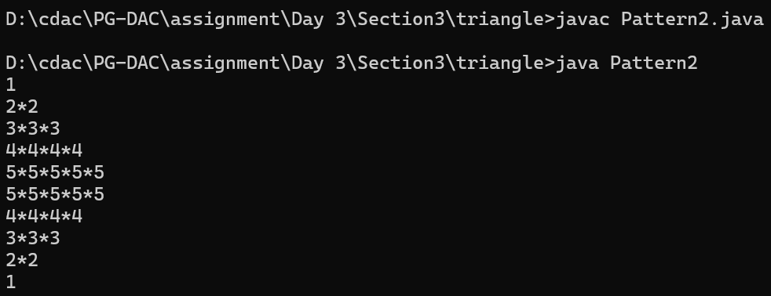

14. Write a program to print the following pattern:

\*

\*\*

\*\*\*

\*\*\*\*\*

\*\*\*\*\*\*\*

\*\*\*\*\*\*\*\*\*   
  
Input:

class Pattern3{

public static void main(String args[]){

for(int i=1; i<=6;i++)

{

for(int j=1; j<=i;j++)

{

System.out.print("\*");

}

System.out.println();

}

}

}

Output:

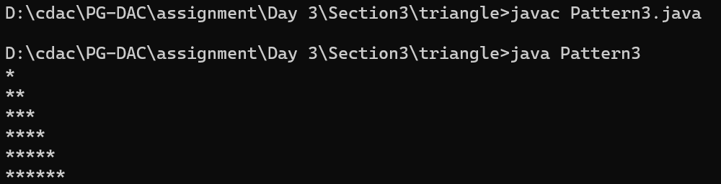

15. Write a program to print the following pattern:

\*

\*\*

\*\*\*

\*\*\*\*

\*\*\*\*\*   
  
Input:

class Pattern4{

public static void main(String args[]){

int n = 5;

for (int i = 1; i <= n; i++) {

for (int j = i; j < n; j++) {

System.out.print(" ");

}

for (int k = 1; k <= i; k++) {

System.out.print("\* ");

}

System.out.println();

}

}

}

Output:

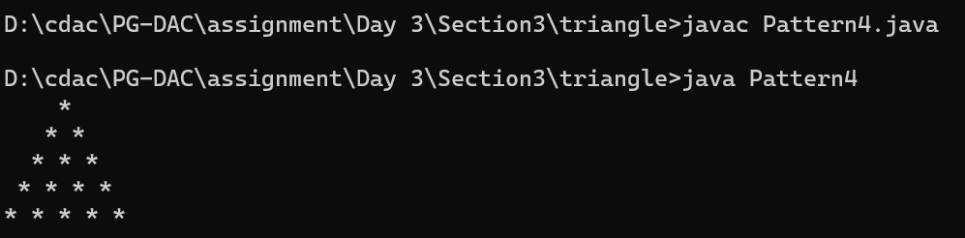

16. Write a program to print the following pattern:

\*

\*\*\*

\*\*\*\*\*

\*\*\*\*\*\*\*

\*\*\*\*\*\*\*\*\*   
  
Input:

class Pattern5{

public static void main(String args[]){

int n = 5;

for (int i = 1; i <= n; i++) {

for (int j = i; j < n; j++) {

System.out.print(" ");

}

for (int k = 1; k <= 2\*i-1; k++) {

System.out.print("\* ");

}

System.out.println();

}

}

}

Output:

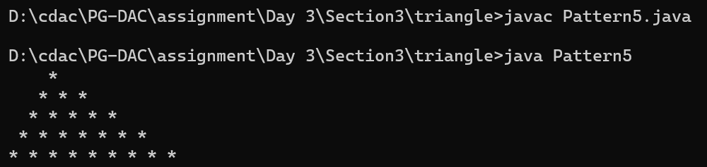

17. Write a program to print the following pattern:

\*\*\*\*\*

\*\*\*\*

\*\*\*

\*\*

\*   
  
Input:

class Pattern6 {

public static void main(String args[]) {

int n = 5;

for (int i = n; i >= 1; i--) {

for (int j = i; j < n; j++) {

System.out.print(" ");

}

for (int k = 1; k <= i; k++) {

System.out.print("\* ");

}

System.out.println();

}

}

}

Output:

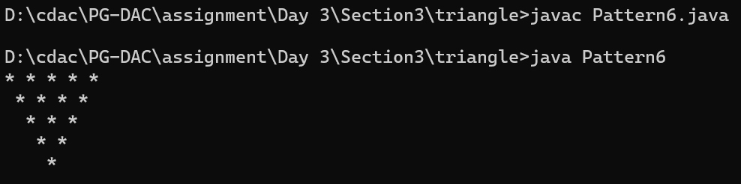

18. Write a program to print the following pattern:

\*

\*\*\*

\*\*\*\*\*

\*\*\*\*\*\*\*

\*\*\*\*\*

\*\*\*

\*   
  
Input:

class Pattern7{

public static void main(String args[]){

int n = 3;

for (int i = 1; i <= n; i++) {

for (int j = i; j < n; j++) {

System.out.print(" ");

}

for (int k = 1; k <= 2\*i-1; k++) {

System.out.print("\* ");

}

System.out.println();

}

for (int i = 4; i >= 1; i--) {

for (int j = i; j < 4; j++) {

System.out.print(" ");

}

for (int k = 1; k <= i; k++) {

System.out.print("\* ");

}

System.out.println();

}

}

}

Output:

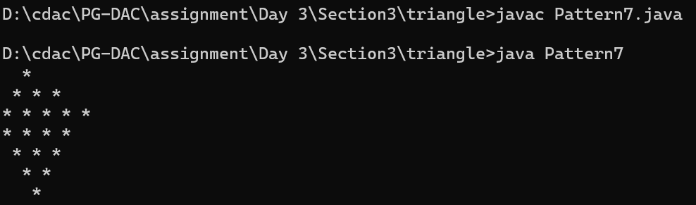

19. Write a program to print the following pattern:

1

1\*2

1\*2\*3

1\*2\*3\*4

1\*2\*3\*4\*5   
  
Input:

class Pattern8{

public static void main(String args[]){

for(int i=1; i<6;i++)

{

for(int j=1; j<=i;j++)

{

System.out.print(j);

if(j<i)

{

System.out.print("\*");

}

}

System.out.println();

}

}

}

Output:

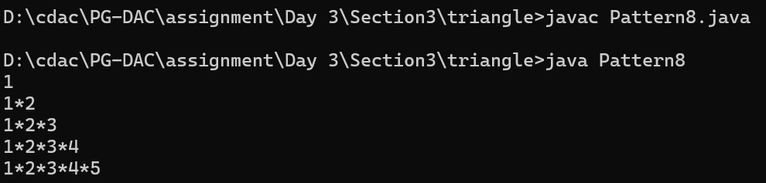

20. Write a program to print the following pattern:

5

5\*4

5\*4\*3

5\*4\*3\*2

5\*4\*3\*2\*1   
  
Input:

class Pattern9{

public static void main(String args[]){

for(int i=5; i>0;i--)

{

for(int j=5; j>=i;j--)

{

System.out.print(j);

if(j>i)

{

System.out.print("\*");

}

}

System.out.println();

}

}

}

Output:

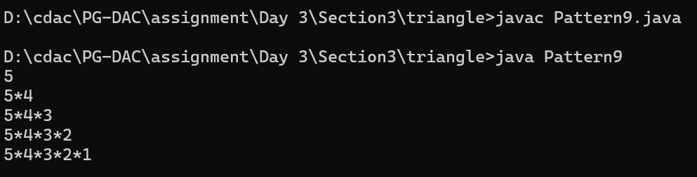

21. Write a program to print the following pattern:

1

1\*3

1\*3\*5

1\*3\*5\*7

1\*3\*5\*7\*9   
  
Input:

class Pattern10{

public static void main(String[] args) {

int n = 5;

for (int i = 1; i <= n; i++) {

int num = 1;

for (int j = 1; j <= i; j++) {

System.out.print(num);

num += 2;

if (j < i) {

System.out.print("\*");

}

}

System.out.println(); // Move to the next line

}

}

}

Output:

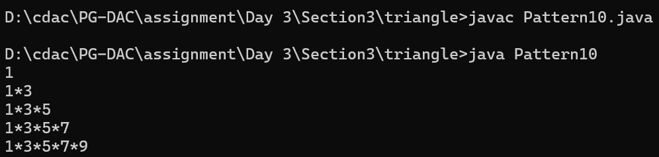

22. Write a program to print the following pattern:

\*\*\*\*\*\*\*\*\*

\*\*\*\*\*\*\*

\*\*\*\*\*

\*\*\*

\*

\*\*\*

\*\*\*\*\*

\*\*\*\*\*\*\*

\*\*\*\*\*\*\*\*\*   
  
Input:

public class Pattern11 {

public static void main(String[] args) {

int n = 5;

for (int i = n; i >= 1; i--) {

// Print leading spaces

for (int j = n; j > i; j--) {

System.out.print(" ");

}

for (int k = 1; k <= (2 \* i - 1); k++) {

System.out.print("\*");

}

System.out.println();

}

for (int i = 2; i <= n; i++) {

for (int j = n; j > i; j--) {

System.out.print(" ");

}

for (int k = 1; k <= (2 \* i - 1); k++) {

System.out.print("\*");

}

System.out.println(); // Move to the next line

}

}

}

Output:

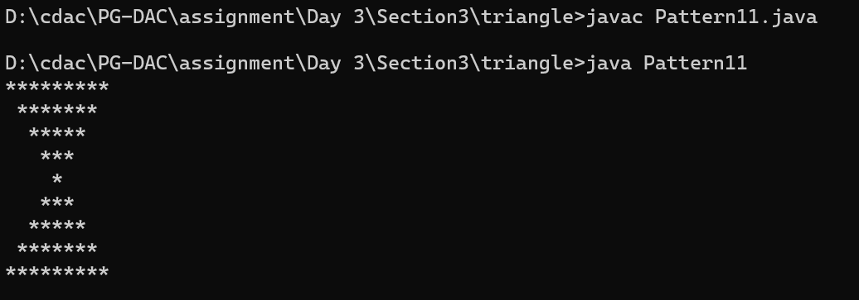

23. Write a program to print the following pattern:

11111

22222

33333

44444

55555

Input:

class Pattern12{

public static void main(String args[]){

for(int i=1; i<6;i++)

{

for(int j=1; j<=5;j++)

{

System.out.print(i);

}

System.out.println();

}

}

}

Output:

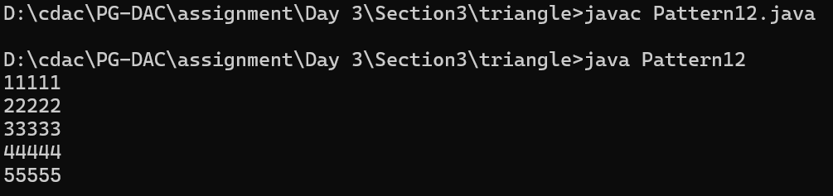

24. Write a program to print the following pattern:

1

22

333

4444

55555   
  
Input:

class Pattern13{

public static void main(String args[]){

for(int i=1; i<6;i++)

{

for(int j=1; j<=i;j++)

{

System.out.print(i);

}

System.out.println();

}

}

}

Output:

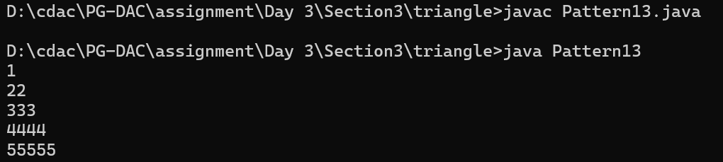

25. Write a program to print the following pattern:

1

12

123

1234

12345   
  
Input:

class Pattern14{

public static void main(String args[]){

for(int i=1; i<6;i++)

{

for(int j=1; j<=i;j++)

{

System.out.print(j);

}

System.out.println();

}

}

}

Output:

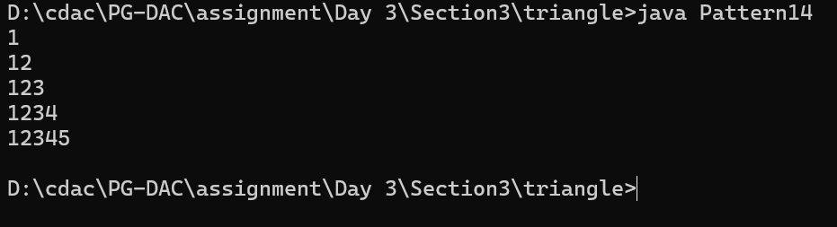

26. Write a program to print the following pattern:

1

2 3

4 5 6

7 8 9 10

11 12 13 14 15

Input:

class Pattern15{

public static void main(String args[]){

int n=1;

for(int i=1; i<6;i++)

{

for(int j=1; j<=i;j++)

{

System.out.print(n+" ");

n++;

}

System.out.println();

}

}

}

Output:

